# DATABASE SYSTEM PRACTICUM REPORT

# MODULE 3

**E-R DIAGRAMS DESIGN WITH DBDESIGNER**



**CREATED BY :**

**KURNIAWAN BAGASKARA**

**L200214253**

# INFORMATICS STUDY PROGRAM

**FACULTY OF COMMUNICATION AND INFORMATION SCIENCE MUHAMMADIYAH SURAKARTA UNIVERSITY**

Test.

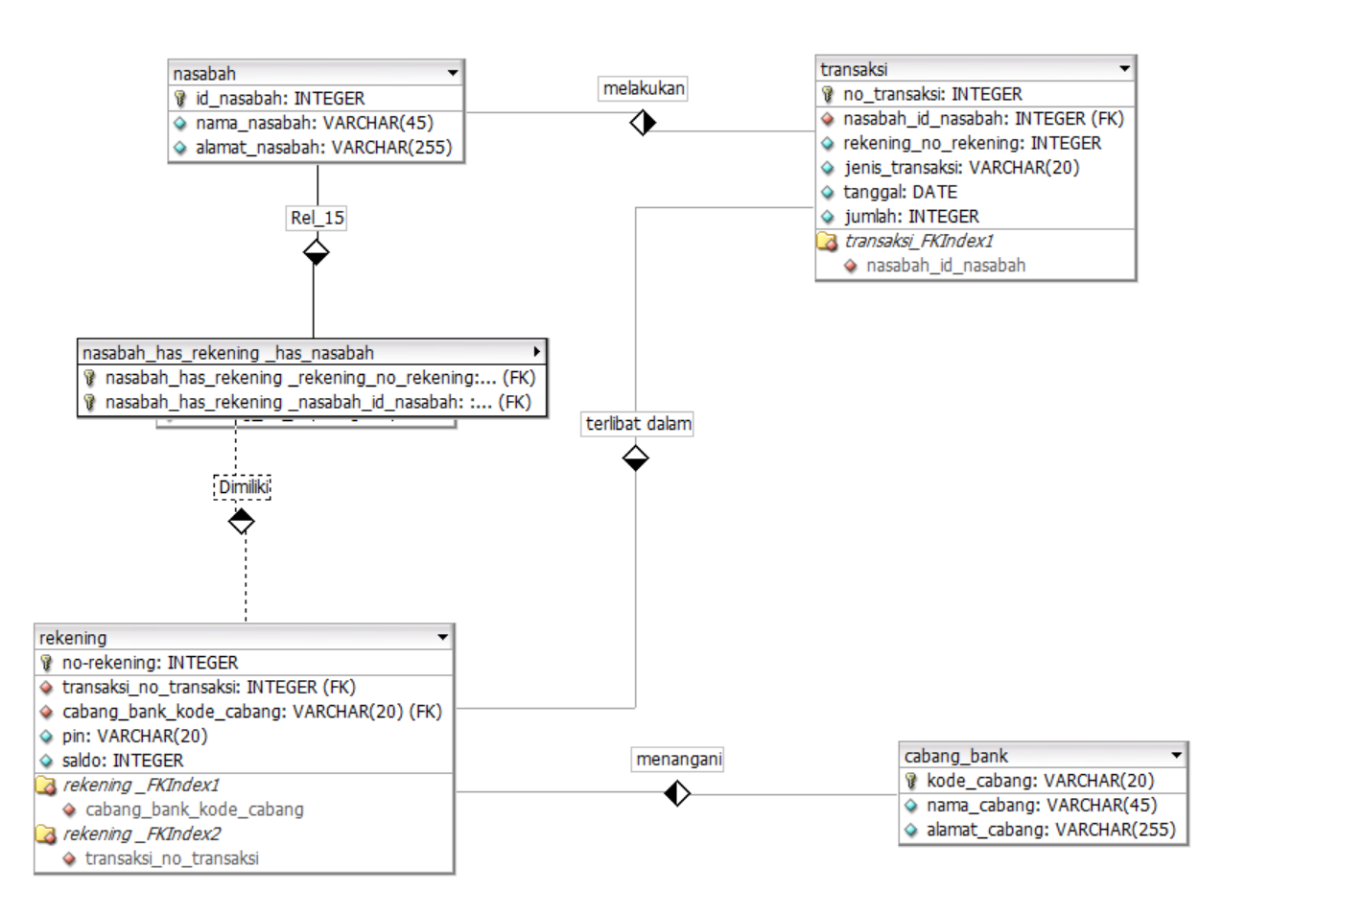

* Define Entity ( Stage 1)

1. Student: store student personal data
2. Lecturer: save the personal data of the lecturer
3. Subject : save course data
4. Classroom : store classroom data

* Determine the attributes of each entity according to the needs of the database ( Stage 2)

1. Student

* NIM : PK
* Name_Student : Varchar (45)
* Address_Student : Varchar (225)

1. Lecturer

* NIDN : PK
* Name_Lecturer : Varchar (45)
* Address_Lecturer : Varchar (225)

1. Subject

* Code_Subject : PK
* Name_Subject : Varchar (45)
* Semester : Varchar (14)
* SKS : Varchar (149)

1. Classroom

* Code_Space : PK
* Capasity : Varchar
* Determine the relationship of each entity ( Stage 3)

|  |  |  |  |  |
| --- | --- | --- | --- | --- |
| Name | Student | Lecturer | Subject | Classroom |
| Student | - | 1:1 | - | - |
| Lecturer | - | - | 1:1 | - |
| Subject | n:1 | - | - | - |
| Classroom | - | - | 1:1 | - |

Releationship :

1. Student Have Lecturer :

* Main Table : Student
* Second Table : Lecturer
* Realationship : *One-to-One (1:1)*
* Connecting attribute : Id_Lecturer ( FK Id_Lecturer in Lecturer )

1. Student Take Subject

* Main Table : Student
* Second Table : Subject
* Relationship : *One-to-Many (1:n)*
* Connecting attribute : Code_Subject ( FK Code_Subject in Subject )

1. Classroom Used Subject :

* Main Table : Subejct
* Second Table : Classroom
* Realationship : *One-to-One (1:1)*
* Connecting attribute : Code_Space ( FK Code_Space in Classroom )

1. Lecturer Guide Subject :

* Main Table : Subject
* Second Table : Lecturer
* Relationship : *One-to-One (1:1)*
* Connecting attribute : Code_Subject ( FK Code_Subject in Subject )
* Draw ERD Diagrams

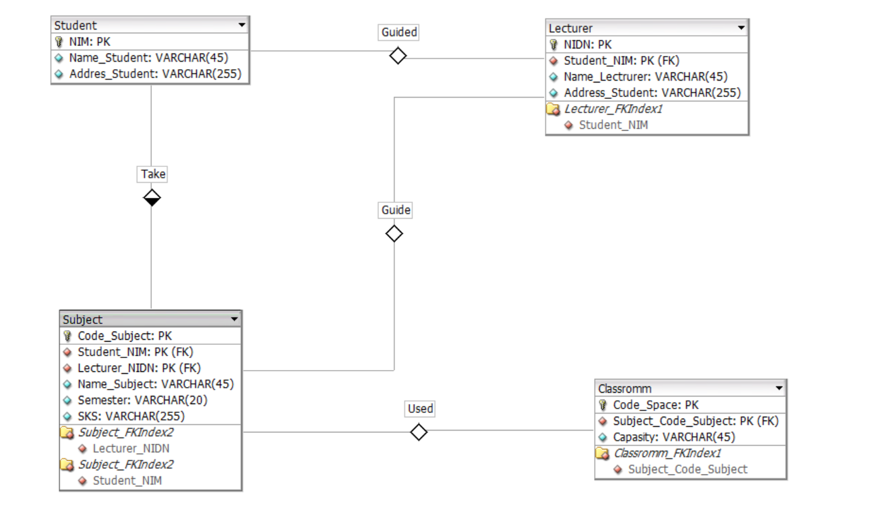

* Define Entity (Stage 1)

1. User
2. Product
3. Store
4. Order

* Determine the attributes of each entity according to the needs of the database ( Stage 2)

1. User

* Id_User : Integer
* User_Name : Varchar(45)

1. Product

* Id_Product : Integer
* Product_Name : Varchar(225)
* Product_Price : Integer
* Product_Stock : Integer

1. Store

* Id_Store : Integer
* Store_Name : Varchar(225)

1. Order

* Id_Order : Integer
* Order_Time : Date
* Determine the relationship of each entity ( Stage 3)

|  |  |  |  |  |
| --- | --- | --- | --- | --- |
| Name | User | Product | Store | Order |
| User | - | - | - | 1:n |
| Product | - | - | - | n:1 |
| Store | 1:1 | 1:n | - | - |
| Order | - | - | 1:1 | - |

1. User Orders Order

* Main Table : User
* Second Table : Order
* Relationship : *One to Many (1:n)*
* Connecting attribute : Id_User( FK Id_User in Order )

1. Store Have Product

* Main Table : Store
* Second Table : User
* Relationship : *One to one (1:1)*
* Connecting attribute : Id_Store ( FK Id_Store in User )

1. Store Own Product

* Main Table : Store
* Second Table : Store_Own_Product
* Relationship : *One to Many (1:n)*
* Connecting attribute : Id_Store ( FK Id_Store in Product )

1. Product Owned Order

* Main Table : Product
* Second Table : Product_Owned_Order
* Relationship : *Many to One(1:n)*
* Connecting attribute : Id_Product ( FK Id_Product in Order )

1. Order Owned Store

* Main Table : Order
* Second Table : Order_Owned_Store
* Relationship : *One to one (1:1)*
* Connecting attribute : Id_Order ( FK Id_Order in Store )
* Draw ERD Diagrams ( Stage 4)

